

**My Page: eClaim App**

Documentation

3rd June 2020

**Abstract**

This document defines the features and functionalities for the eClaim module in the Sistem RKK (SRKK) My Page system.

Contents

Accessing Timesheet 3

eClaim PowerApps 4

Create Monthly Claim 4

User View 4

User Dashboard information 5

Sub Categories Form (User) information 8

Manager View 10

Due Date Form (Manager) information 12

HR View 15

Due Date Form (HR) information 17

eClaim Process Flow 20

# Accessing Timesheet

To access the **eClaim System** page, from the SRKK intranet portal homepage, select the **My Page** link.

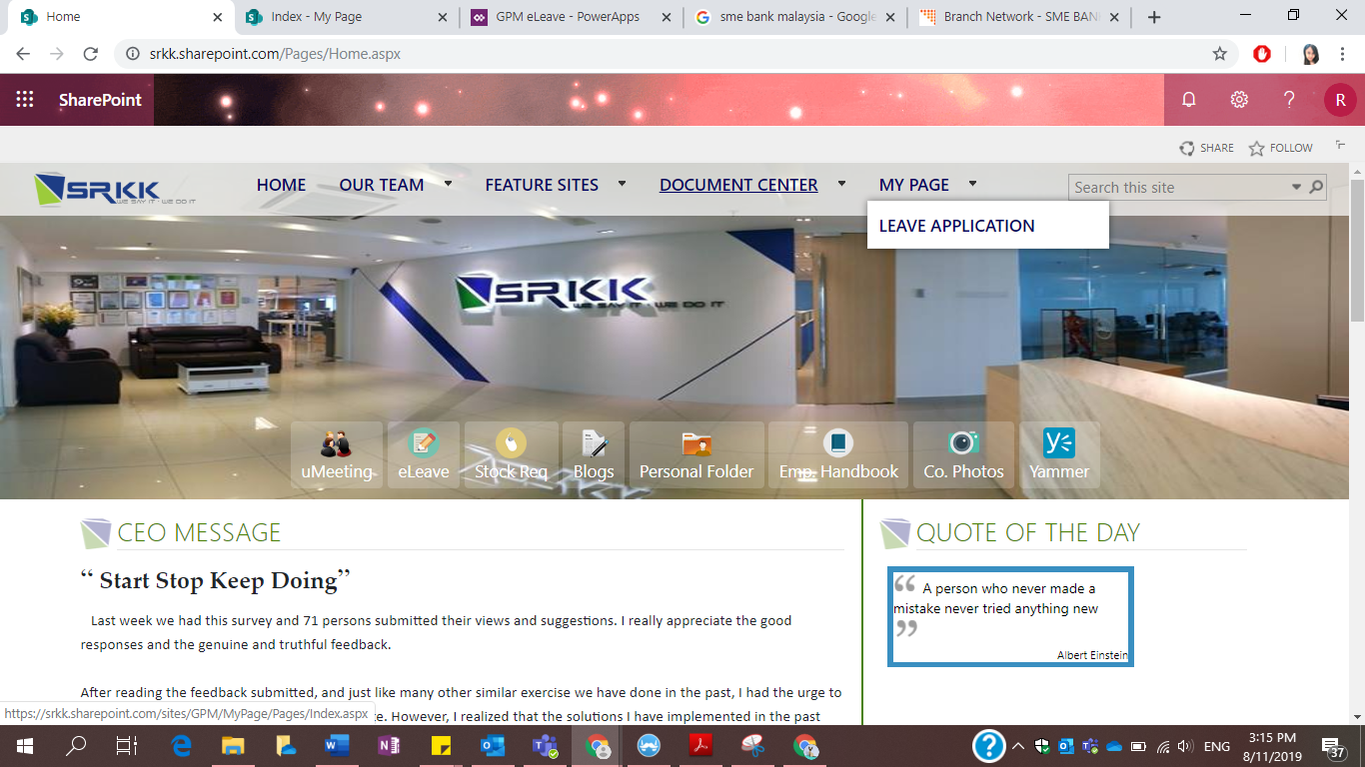

Users will be re-directed to their **MyPage** landing page. On the left navigation pane, select **eClaim**.

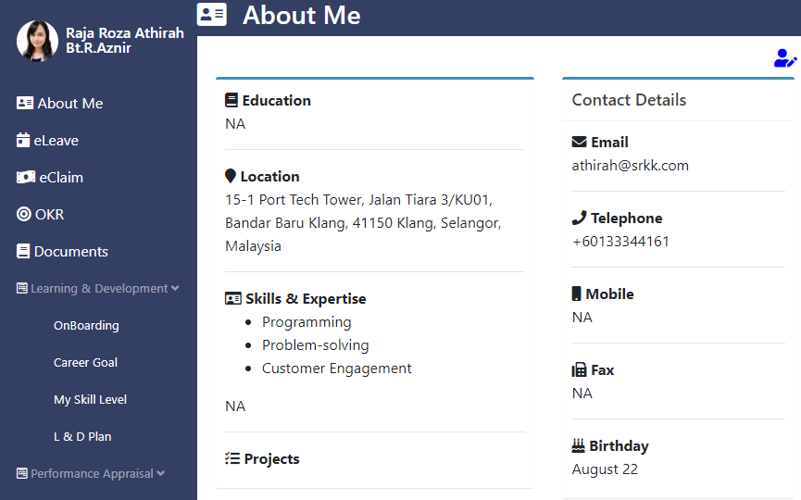

The page will display the summary of claims made by the user.

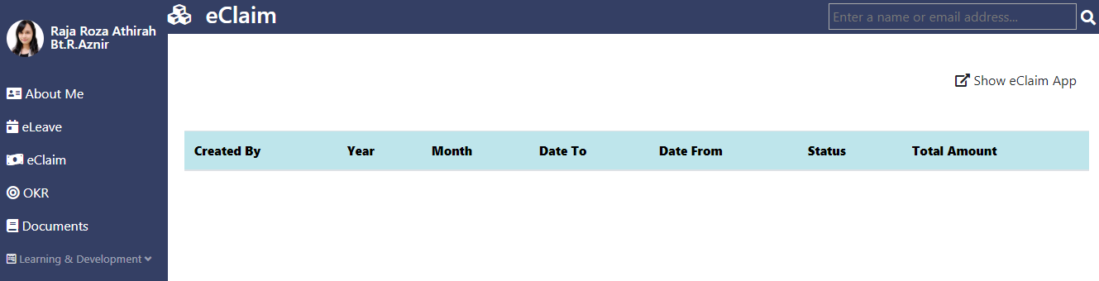

# eClaim PowerApps

## Create Monthly Claim

The page will be re-directed to the PowerApps environment. The application starts with the home page of the app which displays buttons to **Create Monthly Claim, My Dashboard, Manager Dashboard and HR Dashboard.**

To create a claim for that particular month, select the **Create Monthly Claim** button on the home page.

The page will be re-directed to the Monthly Claim form page. User need to fill in their monthly claim information which are the **Year**, **Month**, **Date From** and **Date To**.

## User View

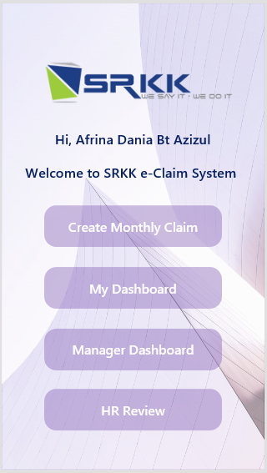 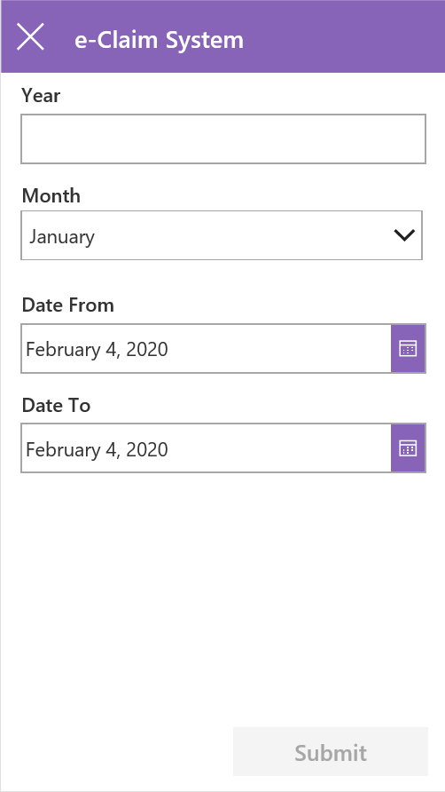

Submit button displayed at the right bottom navigation pane, the button will be will be available for select once the user fill in the required field in form which is the **Year** field and updated the data in a SharePoint list.

When user clicked the **Submit** button in **Create Monthly Claim** page and **My Dashboard** in **Home page,** user will be re-directed to this page called **User’s Dashboard**.

In **User’s Dashboard** page, there are four button navigation at the bottom of this screen consists of **Draft**, **Pending**, **Approved** and **Recheck** button. **Draft** button is set to default as it will automatically re-directed to **Draft** screen once user click the **My Dashboard** button.

 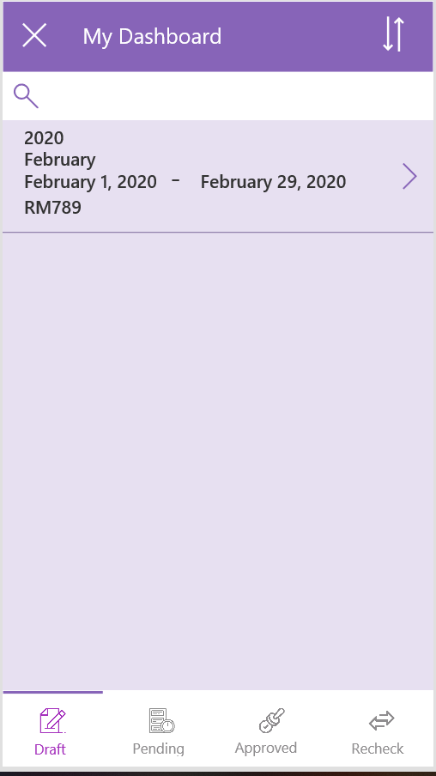

4

**3**

**2**

**1**

### User Dashboard information

|  |  |  |
| --- | --- | --- |
| No. | Feature | Description |
| 1 | Draft button | Claim that have not been submitted yet to Manager. |
| 2 | Pending button | Claim that have been submitted to Manager and HR and waiting for approval from them. |
| 3 | Approved button | Approved claim expenses from both Manager and HR. |
| 4 | Recheck button | Rejected claim from Manager and HR and need action from user to resubmit back before due date. |

The functionalities for the **Sort icon** is to sort the dashboard in ascending or descending order.

User have to click on the gallery or the **> symbol** to add their claim expenses for that month. Next, user will be re-directed to this page. Users monthly claim details will be displayed at the upper part of the screen and the claim expenses details is at the bottom part.

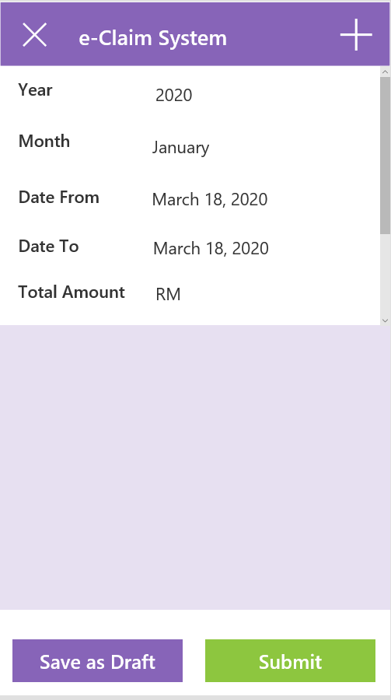

To add a new claim expenses, select **+ icon** located at the upper right of the screen. Users will then be re-directed to the **Main Categories** page.

This page displays the main categories given by finance department. Users may choose whichever main categories that is related to their claim expenses.

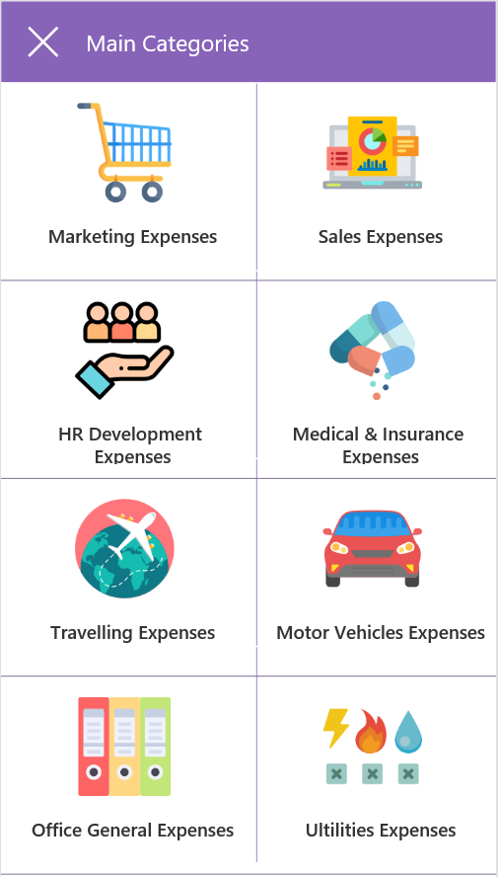

Once user clicked the main categories, user will be re-directed to sub categories page where user need to key in all the claim expenses amount and attach the receipt.

***\*Note:*** *User must choose the date in range of the selected Date From and Date To. Error will pop up if user select wrong date and Save button will be disabled.*

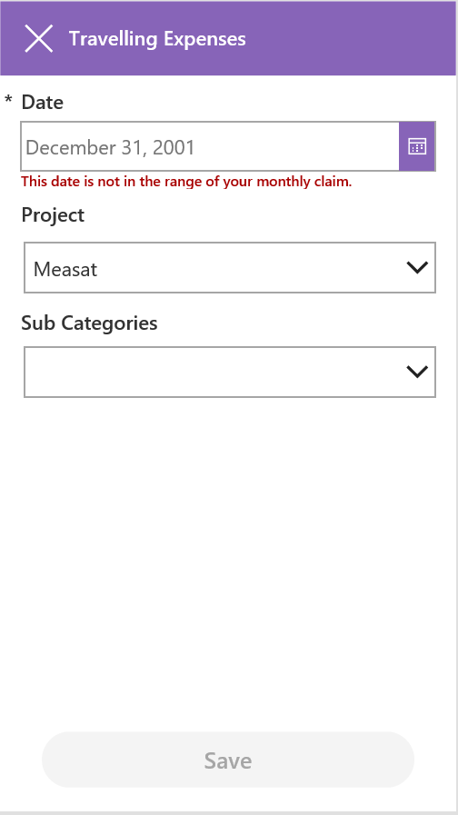 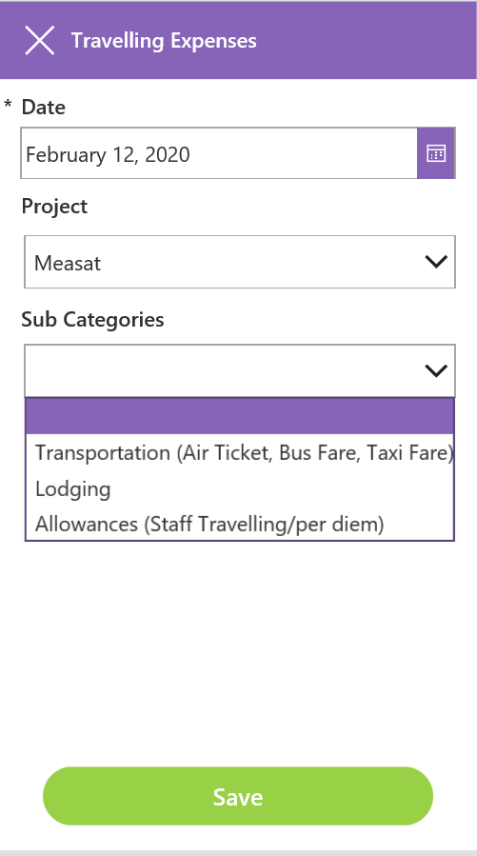 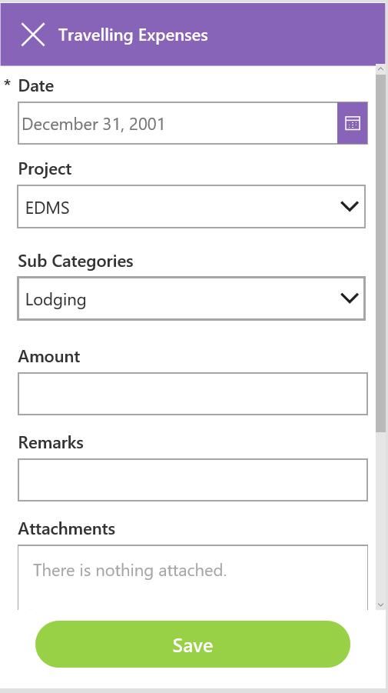

Users will enter the **Date,** choose the active **Project,** and **Sub Categories.** Next, fill in **Amount**, **Remarks** and **Attachments** field. Once done. Select **Save** button on the bottom of the screen.

### Sub Categories Form (User) information

|  |  |  |
| --- | --- | --- |
| No. | Feature | Description |
| 1 | Date | A calendar-based menu to select the date for the claim (Date range between Date To and Date From) |
| 2 | Project menu | A dropdown menu of existing and on-going projects. Select a project wherein the claim will be associated with. |
| 3 | Sub Categories | A dropdown menu of sub categories based on the chosen main category. |
| 4 | Amount | Amount of the expenses (refer to the receipt) |
| 5 | Remarks | Any additional information (not required) |
| 6 | Attachment | A picture of receipt to be attach to. |

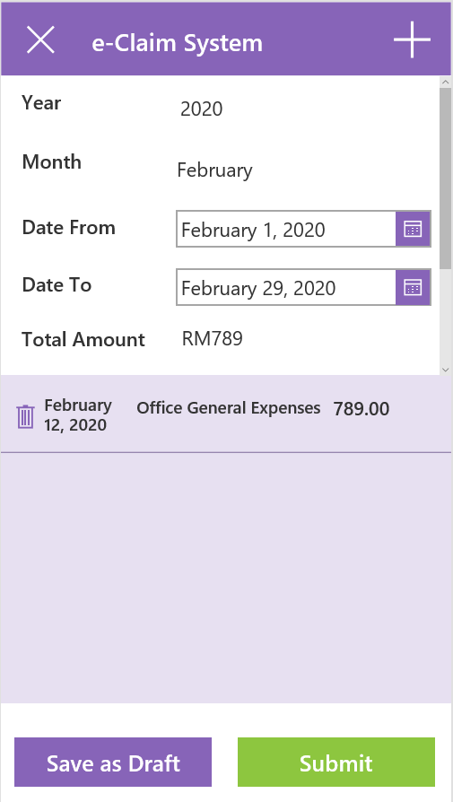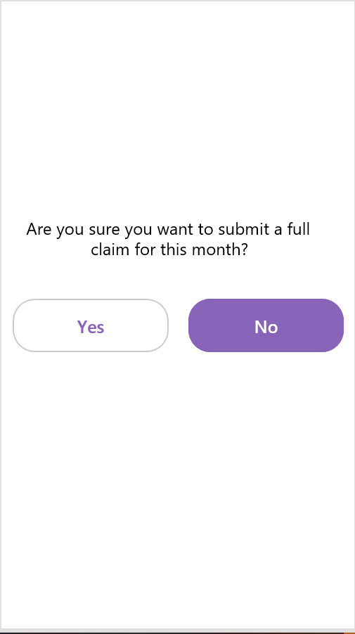

All of the expenses will be displayed in the gallery once it is save by the user. If the claim’s date has not been announced by HR, user have to select **Save as Draft** button and it will save their expenses.

**Submit** button located at the bottom right of the page is been selected once HR announced the date to submit claim for that particular month. User will be re-directed to the **Confirmation Page** once they clicked it.

User can delete the expenses if they have key in or attach wrong information by clicking the **Trash** icon at the upper left corner of the screen.

**Yes** button to proceed submitting the claim to Assigned Manager and **No** button is to cancelled submission of claim.

## Manager View

To access the **Manager Dashboard**, select the **Manager Dashboard** button on the home page.



The page will be re-directed to the **Manager Dashboard**. The dashboard consists of all of his/her staff that is assigned under the **Manager**.

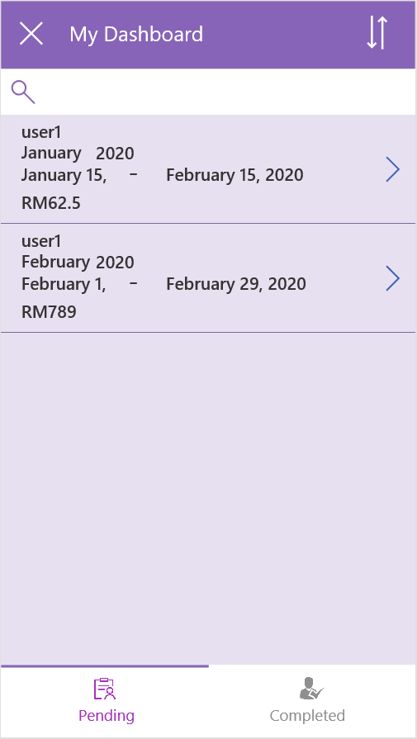

②

|  |  |  |
| --- | --- | --- |
| No. | Feature | Description |
| 1 | Pending button | Awaiting claim to be approve by assigned Manager. |
| 2 | Approved button | Approved employee’s claim and sent to HR to second approval |

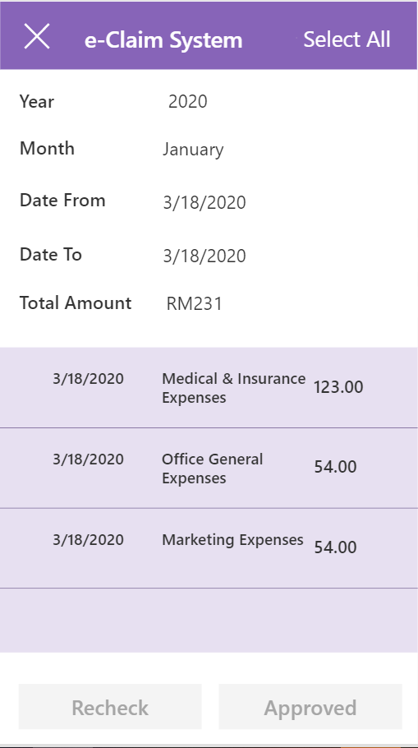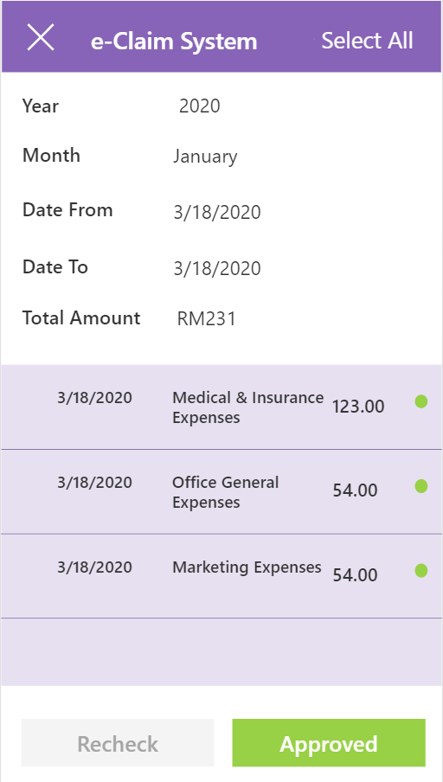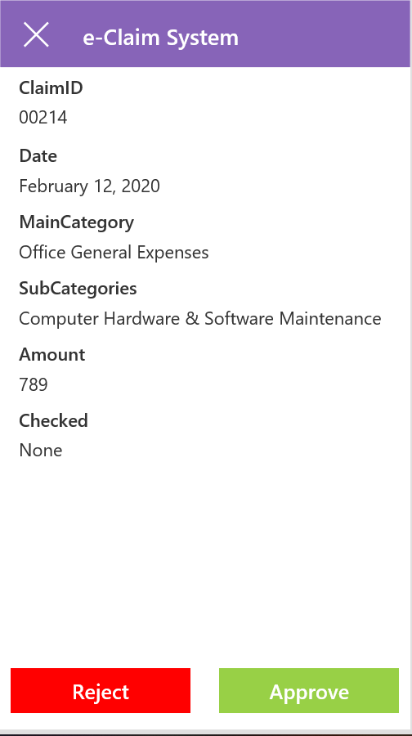

There are two-ways for **Manager** to approved their employee’s claim. The first way is by select the **Select All** button located at the upper right corner and all expenses will automatically approved. **Approved** button will be available to select.

The other way for **Manager** to approved is by select one-by-one claim expenses and select either to **Approve** or **Reject** the claim.

**Green indicator** will show if **Manager** approve the claim and **Red indicator** is when **Manager** reject the claim. **Recheck** button at the bottom of the page will be available to select if there is one or more rejected claim.

If Manager clicked the **Recheck** button, the page will be re-directed to the **Due Date** page for Manager to key in the due date and comments for the rejected claim.

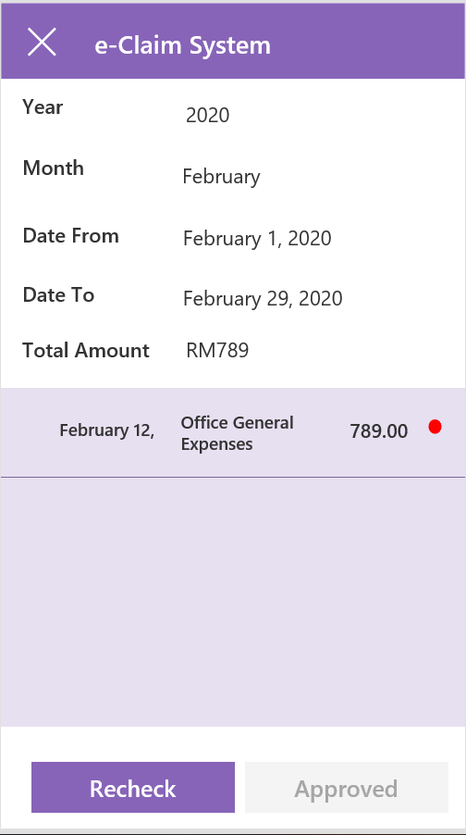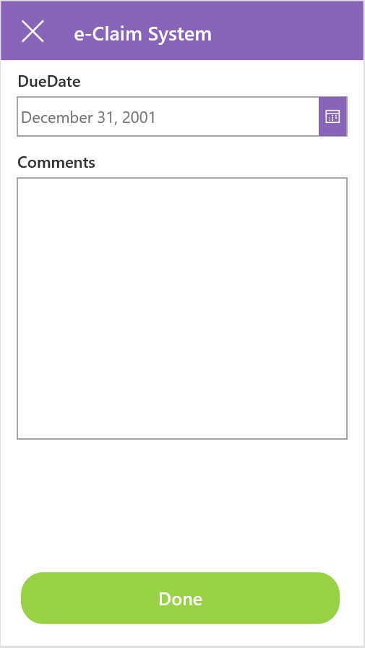

Once Manager clicked Done button, the employee will receive an email notification regarding the rejected claim and they need to resubmit back to Manager before the due date.

### Due Date Form (Manager) information

|  |  |  |
| --- | --- | --- |
| No. | Feature | Description |
| 1 | Due Date | A calendar-based menu to select the end-date for the claim. |
| 2 | Comments | Any comments about the rejected claim. |

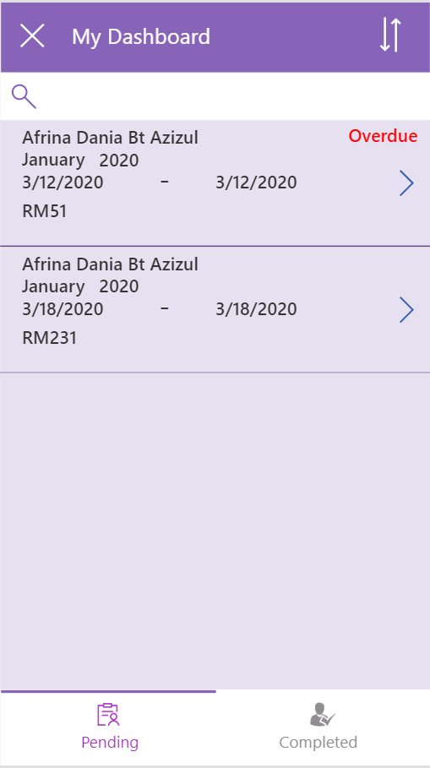

**Overdue** label will appear when the due date has past and employee is not giving any action or response. Manager can proceed the claim by delete the rejected one and approved the rest.

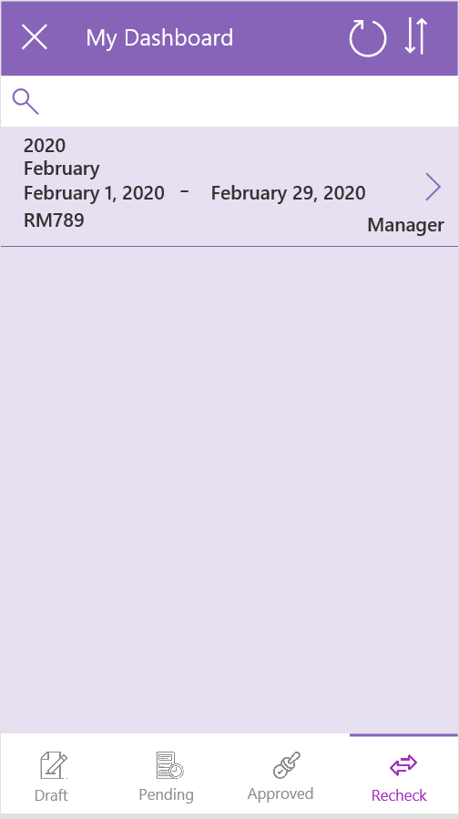

All claims with rejected claim expenses in it will goes under **Recheck** button for employee do the correction and resubmit back to Manager.

## HR View

To access the **HR Dashboard**, select the **HR Review** button on the home page.



The page will be re-directed to the **HR Dashboard**. The dashboard consists of all the company’s employee.

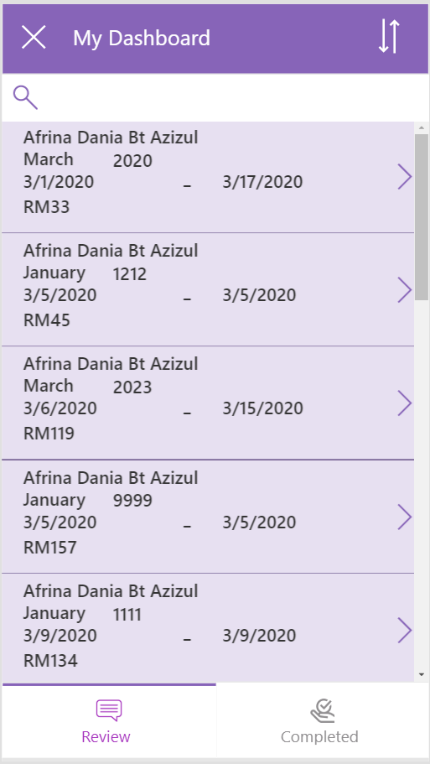

②

|  |  |  |
| --- | --- | --- |
| No. | Feature | Description |
| 1 | Review button | Claim that have been approved by Manager but waiting for HR approval. |
| 2 | Completed button | Claim that is approved by both Manager and HR. |



There are two-ways for HR to approved their employee’s claim. The first way is by select the **Select All** button located at the upper right corner and all expenses will automatically approved. **Approved** button will be available to select.

The other way for HR to approved is by select one-by-one claim expenses and select either to **Approve** or **Reject** the claim.

**Green indicator** will show if HR approve the claim and **Red indicator** is when HR reject the claim. Recheck button at the bottom of the page will be available to select if there is one or more rejected claim.

If HR clicked the **Recheck** button, the page will be re-directed to the **Due Date** page for HR to key in the due date and comments for the rejected claim.



Once HR clicked Done button, the employee will receive an email notification regarding the rejected claim and they need to resubmit back to HR before the due date.

### Due Date Form (HR) information

|  |  |  |
| --- | --- | --- |
| No. | Feature | Description |
| 1 | Due Date | A calendar-based menu to select the end-date for the claim. |
| 2 | Comments | Any comments about the rejected claim. |



**Overdue** label will appear when the due date has past and employee is not giving any action or response. HR can proceed the claim by delete the rejected one and approved the rest.



All claims with rejected claim expenses in it will goes under **Recheck** button for employee do the correction and resubmit back to HR.

# eClaim Process Flow

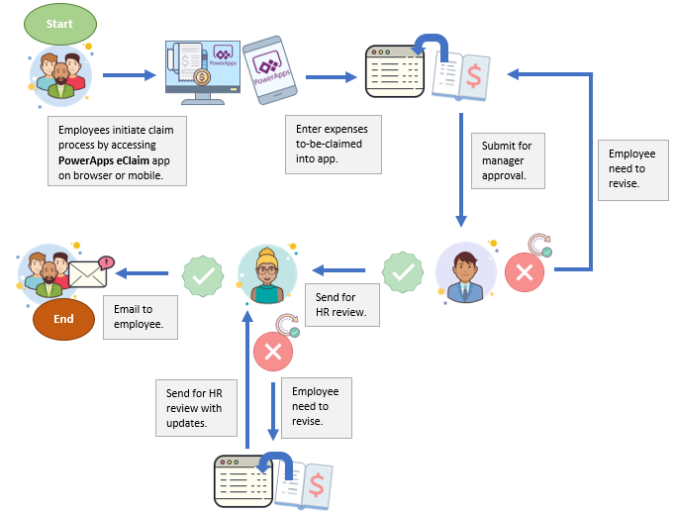

*eClaim System Mobile Application High Level Process Flow*